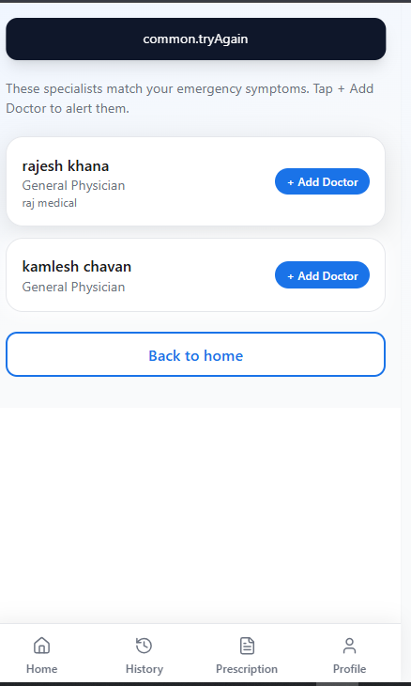

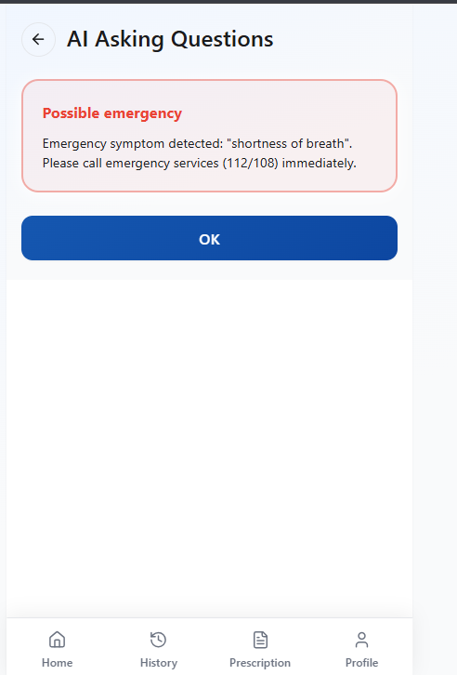
Make sure after emergency screen occur then
No need to open another screen. add this flied in bellow possible emergency card and above the ok button . Make sure the button work properly add +add doctor button work properly.

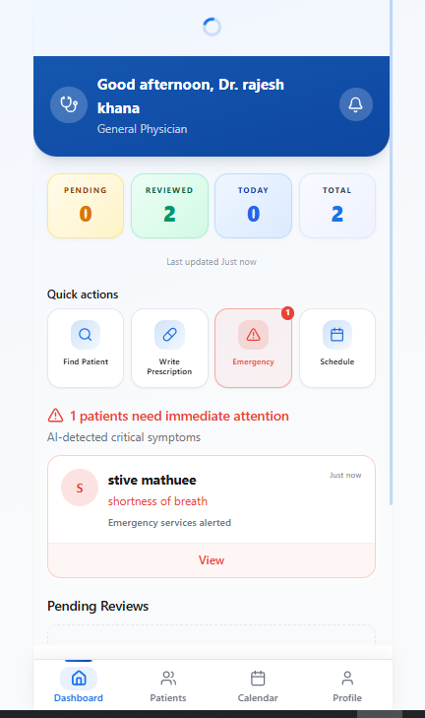
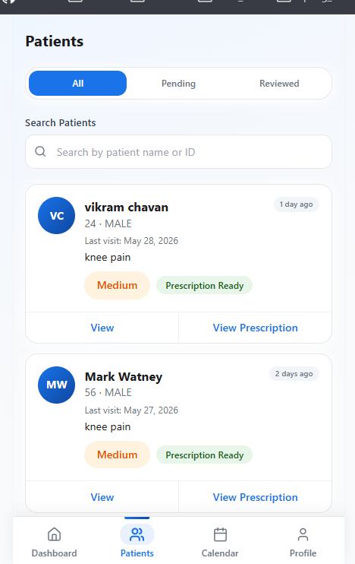

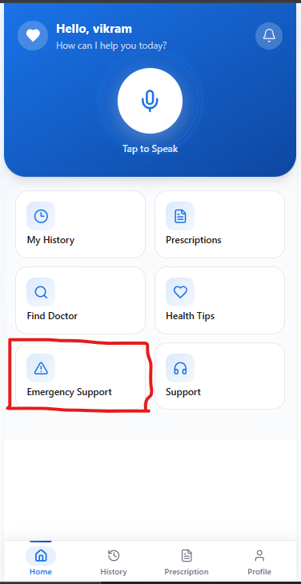
after doctor review emergency then patient dashboard show Emergency support show the status with doctor name.
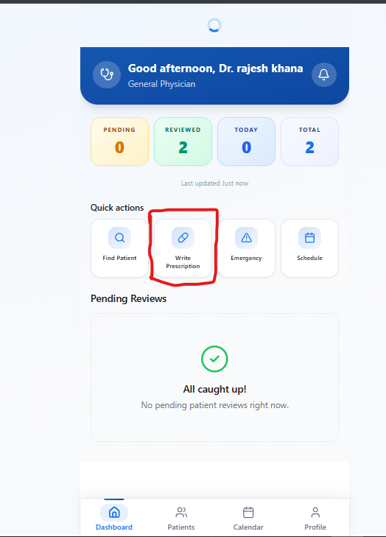
I doctor dashboard has write Prescription button. Just change the name from Prescription’s. in this button show the all past patient Prescription’s medical history.

